Homeostasis and Control
Name
Institution
Date

Homeostasis and Control
Question One
Differentiate between homeostasis and steady-state.
Homeostasis is the ability of the body to maintain a constant internal environment in response to external changes. According to Lakhal-Littleton (2019), homeostasis can as well be understood as any self-regulating process in which biological systems tend to maintain stability while adjusting to conditions that are optimal for survival. Without the success of homeostasis, then life cannot be successful since the body cannot correct the changes in body systems, and this implies death is most likely to occur. An excellent example of hemostasis is in the way the human body regulated temperatures. At times, the body temperatures will either rise or fall beyond the average temperatures, 37 degrees Celsius due to the influence of certain factors like exposure to hormones, metabolic rates and infections. The hypothalamus gets the information about the deviation of body temperatures and then send feedback via the bloodstream to the brain and thus initiating compensatory adjustments in blood sugar and metabolic rate to maintain a constant internal environment. This will result in mechanisms like insulation and decreased circulation of blood to the skin to reduce heat loss. To increase heat loss, the metabolic rates increases and command to remove excessive clothes help in this process.
On the other hand, a steady-state is the ability of the body to remain constant conditions over time, and this continuous state needs continual work. In other words, this steady state is also known as dynamic equilibrium. The specific situation should be evident for the body systems to be said to be in dynamic equilibrium. A system in the steady-state has a higher level of energy than its surroundings. In the process, there are complex biochemical reactions that take place. For example, the blood lactate level in the body should be maintained at a steady-state. This implies that if the lactate level is higher, especially during exercises. The rate of exercising should be lowered to ensure that the lactate levels are maintained steady.
Question Two
Briefly explain the role of the sensor, the integrating center, and the effector organ in a biological control system.
The biological control system involves the interconnection of various components that serve to maintain the physical and chemical conditions of an organism near constant value. The feedback mechanisms are essential in the biological control systems. The system also contains a sensor which is defined as a system that detects changes in the body conditions (Freedberg et al., 2017). The factors that bring about change in body systems are called stimuli. Sensors are found in the skin for detecting touch, in the tongue for detecting taste, in the eyes for vision by detecting light and in the nose for smell reception. Additionally, there are sensors for temperatures and balance sensors. The primary function f sensors are to detect changes in or outside the body and thus initiating the control process.
The integrating center is a critical part of the body in the brain, specifically the hypothalamus that signals a part of the body to respond to stimulus. The integrating center has mainly the central nervous system (CNS) consisting of the brain and spinal cord, and their main function is to integrate information internally to communicate the output (Freedberg et al., 2017). More importantly, the integrating center provides instructions to the body through the CNS. The effector organs are the special organs refers to organs specialized to respond to stimulus, especially a nerve impulse. These organs include glands, muscles or even organ cell capable of responding to the stimulus at the terminal end of an efferent nerve fiber. It is worth noting that the biological control systems need effective coordination of sensory organs, integrating center and then effector organs to bring feedback in response to the stimuli.

Question Three
Draw a simple diagram that demonstrates the relationship between the components of a biological control system. Be sure to identify each part.
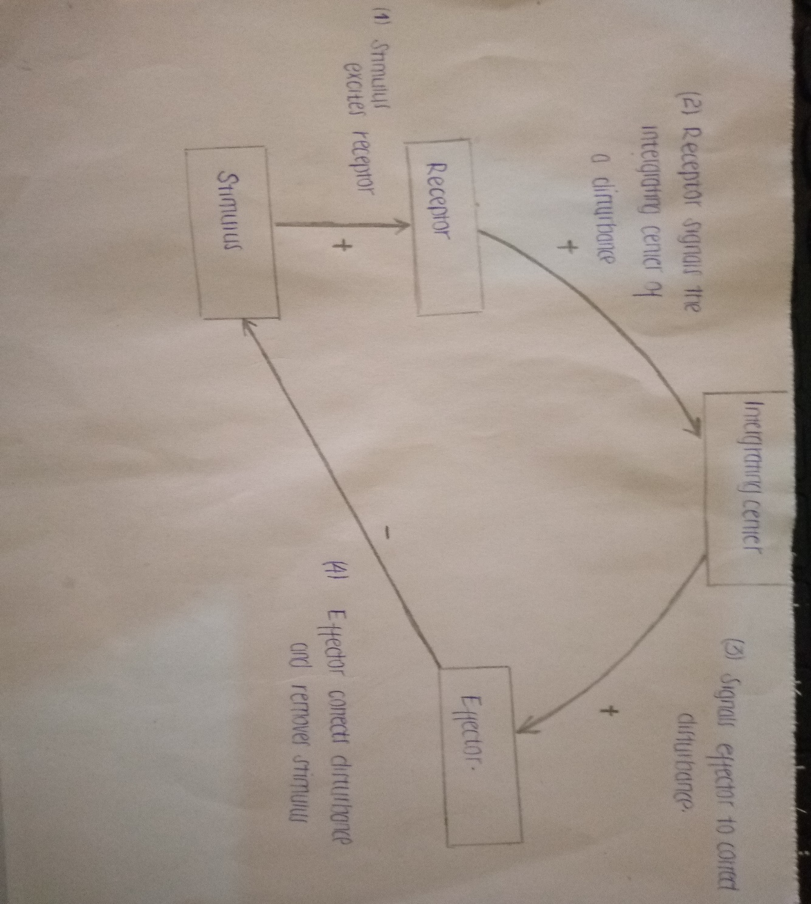

Question Four
Explain the terms of negative feedback and positive feedback. Give a biological example of negative feedback.
Negative feedback is a reaction in response to some stimulus that leads to a decrease in functions. Usually, the feedback causes the system to get stabilized, and thus it brings back body conditions to normal (Freedberg et al., 2017). Examples of negative feedback include the regulation of human body temperatures, especially when below average, the hypothalamus of a human responds by initiating shivering to generate heat. If the temperature is too high, then hypothalamus will initiate sweating to cool down the body. On the other hand, positive feedback occurs to increase the output or change, and this occurs more quickly. In homeostasis, positive feedback moves the system further from the target equilibrium (Ozbay, 2019). For example, in the initiation of childbirth, the receptor in the cervix receive this essential impulse and send message to the brain, which in turn leads to the release of oxytocin from the pituitary gland. The oxytocin initiates the contraction of uterine walls.
Question Five
Discuss the concept of gain associated with a biological control system.
Gain is the capability of a system to maintain homeostasis (Ozbay, 2019). It is the magnitude of the input to the magnitude of the output in a steady state. A control system having a significant gain is more capable of maintaining homeostasis as compared to a control system with a low gain. For instance, pulmonary and cardiovascular systems have large gains.

References
Freedberg, M., Glass, B., Filoteo, J. V., Hazeltine, E., & Maddox, W. T. (2017). Comparing the effects of positive and negative feedback in information-integration category learning. Memory & cognition, 45(1), 12-25.
Lakhal-Littleton, S. (2019). Mechanisms of cardiac iron homeostasis and their importance to heart function. Free Radical Biology and Medicine, 133, 234-237.
Ozbay, H. (2019). Introduction to feedback control theory. Routledge.

